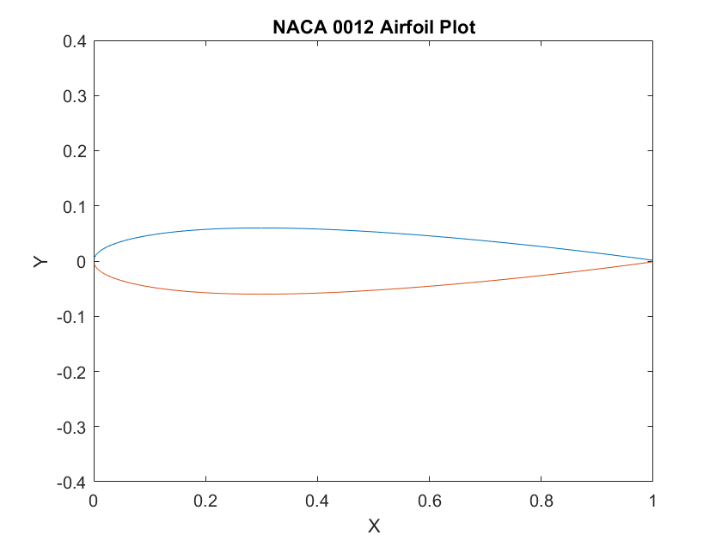

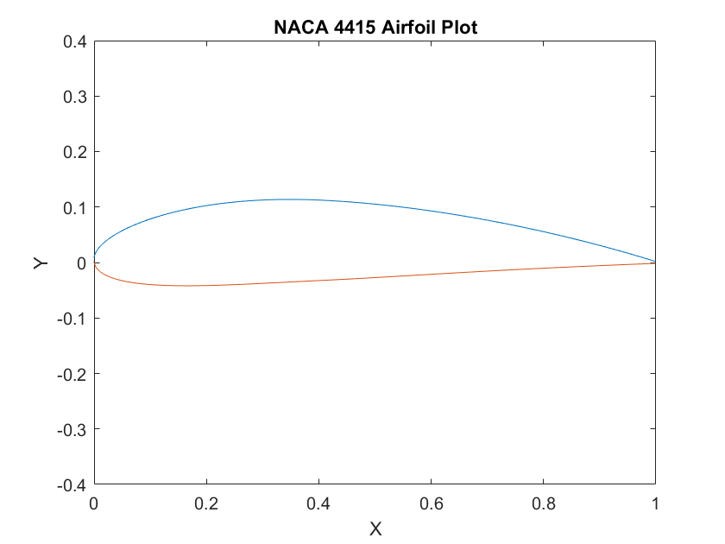

%% NACA 0012

m = 0; % Camber

p = 0; % Position

t = 0.12; % Thickness

%% NACA 4415

m = 0.04; % Camber

p = 0.4; % Position

t = 0.15; % Thickness

%%

% Sets up values for x in increments of 0.01

length = 1000;

yc = zeros(1,length);

theta = zeros(1,length);

x = 0:0.001:1;

% Using a for loop to calculate yc, theta, yt

for i = 1:length

% The if statment allows us to calculate yc and theta with the condition

% for whe x < p and and x is greater than p.

if (x(i) >= 0) && (x(i) <= p)

yc(i) = m*(2*p*x(i) - x(i)^2)/p^2;

theta(i) = atan((2*m*(p-x(i)))/p^2);

else

yc(i) = m*(1-2*p + 2*p*x(i) - x(i)^2)/(1-p)^2;

theta(i) = atan((2*m*(p-x(i)))/(1-p)^2);

end

% the yt is then calculated

yt(i) = (t/0.2)*(0.2969*sqrt(x(i)) - 0.1260*x(i) - 0.3516*x(i)^2 ...

+ 0.2843*x(i)^3 - 0.1015*x(i)^4);

% The x and y coordinates for the lower and upper bounds can then be

% calculated and plotted.

X_U(i) = x(i) - yt(i)*sin(theta(i));

X_L(i) = x(i) + yt(i)*sin(theta(i));

Y_U(i) = yc(i) + yt(i)*cos(theta(i));

Y_L(i) = yc(i) - yt(i)*cos(theta(i));

end

plot(X_U,Y_U)

hold on

plot(X_L, Y_L)

hold off

axis([0 1 -0.4 0.4])

xlabel('X')

ylabel('Y')

%title('NACA 4415 Airfoil Plot')

title('NACA 0012 Airfoil Plot')